Security Operations Center (SOC) Lab Documentation

Detection Engineering: Windows Brute-Force Attack Using Wazuh SIEM
Prepared By: Paulson k Babu
Date: 11 February 2026
Platform: Wazuh SIEM / XDR
Classification: Lab / Educational Use

1. Executive Summary
This document details the configuration, testing, and validation of a custom brute-force detection rule in Wazuh SIEM. Initially, individual Windows authentication failures were logged as standard 'login failed – bad username or password' events. After implementing a frequency-based correlation rule, multiple failed login attempts within a defined timeframe were successfully escalated as a brute-force alert. This exercise demonstrates practical SOC detection engineering, log correlation, and MITRE ATT&CK mapping.

2. Objective
The objectives of this lab exercise were:
• To understand how Windows authentication failures are logged and processed by Wazuh
• To create and deploy a custom correlation rule in local_rules.xml
• To detect brute-force behavior using frequency and timeframe logic
• To validate alert generation in the Wazuh Dashboard

3. Lab Environment
• Wazuh Manager: Installed on Linux server
• Wazuh Agent: Installed on Windows endpoint
• Log Source: Windows Security Event Logs
• Dashboard: Wazuh Web Interface (Discover Module)
• Rule File Modified: /var/ossec/etc/rules/local_rules.xml

4. Initial Observation (Before Custom Rule)
Before implementing the custom rule, each failed login attempt was logged individually with the description 'Login failed – bad username or password'. No correlation was performed, and no brute-force alert was generated.
Individual failed login events in Wazuh Dashboard.
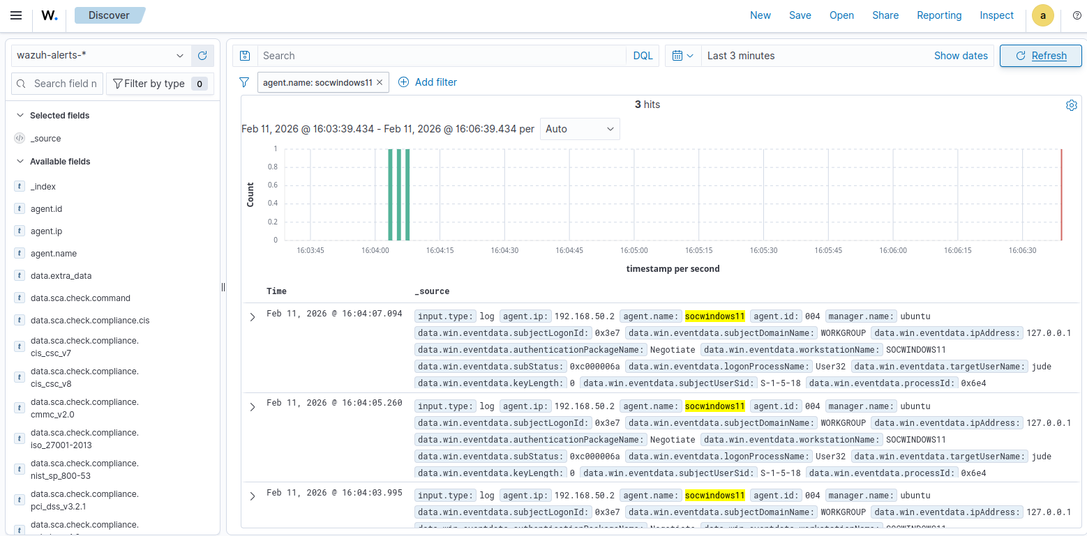
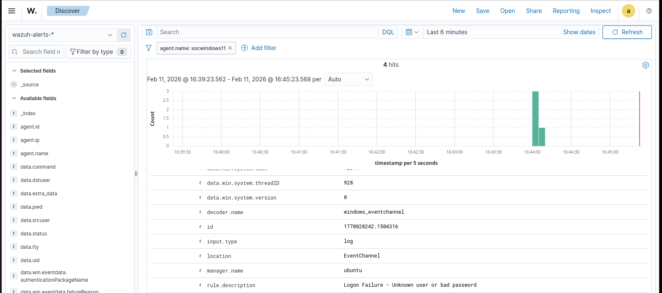

.5. Custom Correlation Rule Implementation
A frequency-based rule was added to local_rules.xml to detect three failed login attempts within 120 seconds.
Variation 1: Using <if_matched_group>authentication_failed</if_matched_group>
Variation 2: Using <if_matched_sid>60122</if_matched_sid> (Recommended)
Rule Parameters:
• frequency = 3
• timeframe = 120 seconds
• level = 12 (High/Critical)
• MITRE ATT&CK Technique: T1110 (Brute Force)

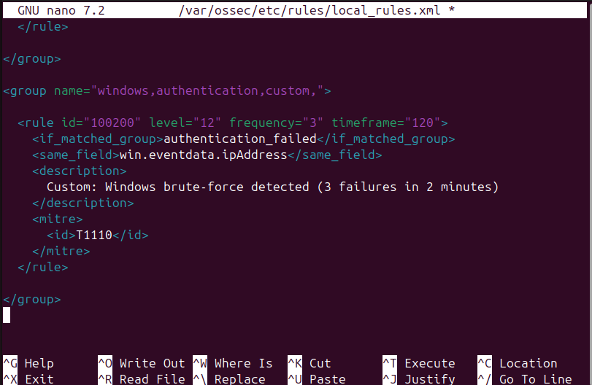

6. Applying Configuration Changes
After saving the rule, the Wazuh Manager service was restarted to apply the configuration changes.
Command Executed: systemctl restart wazuh-manager

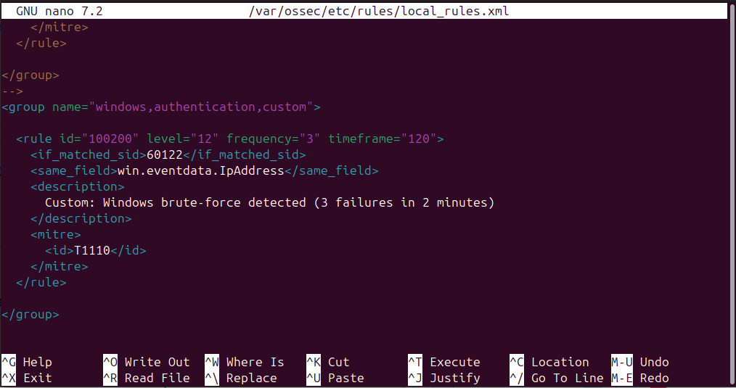

7. Difference Between if_sid and if_matched_sid
• <if_sid> triggers immediately when a single event matches.
• <if_matched_sid> is used for counting multiple matching events.
• Frequency-based correlation requires <if_matched_sid>.
• Using <if_sid> with frequency causes 'Invalid use of frequency' error.

8. Troubleshooting Wazuh Restart Error
<if_sid> triggers the rule immediately when a single event matches the specified rule ID.
<if_matched_sid> is used when you want to count multiple occurrences of that rule within a defined frequency and timeframe.
I corrected it with <if_matched_sid>
Command executed during troubleshooting:
sudo systemctl restart wazuh-manager

9. Brute-Force Simulation
To validate the detection logic, three consecutive failed login attempts were performed on the Windows endpoint within 120 seconds.
Event Flow:
1. Windows generated Security Event logs for failed authentication.
2. Wazuh Agent forwarded logs to Wazuh Manager.
3. Custom rule (ID 100200) correlated three events within timeframe.
4. Brute-force alert was generated.

10. Alert Validation in Dashboard
After three failed login attempts, Wazuh generated a high-severity alert indicating possible brute-force activity.
Observed Alert Details:
• Rule ID: 100200
• Severity Level: 12
• Description: Multiple Windows login failures detected. Possible brute-force attack.
• MITRE Technique: T1110
• Agent: Windows Endpoint
Brute-force alert in Wazuh Discover view.
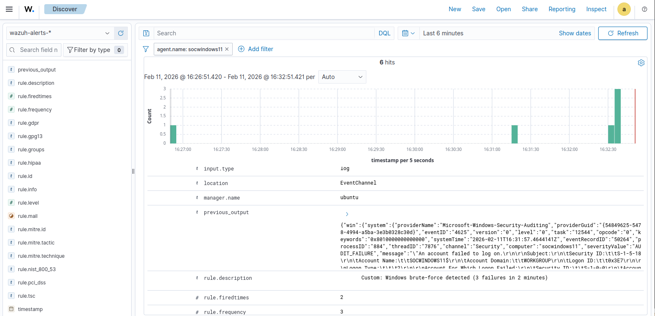

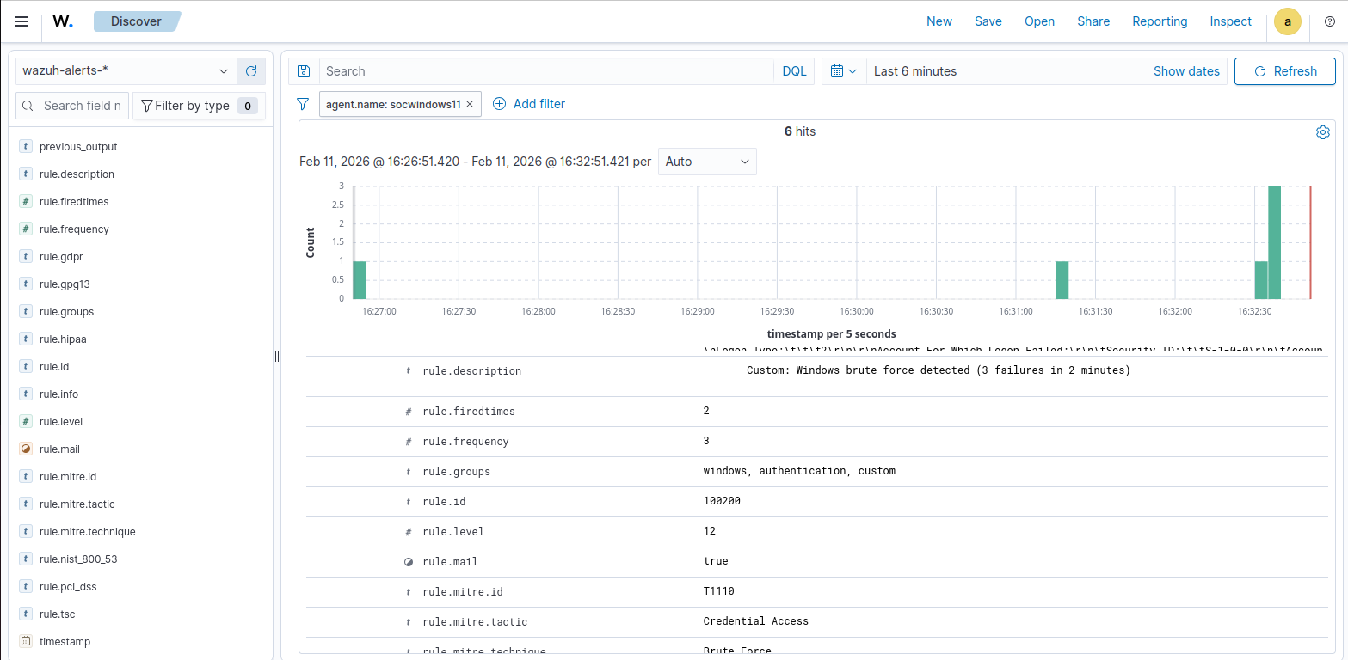

11. Validation in Threat Hunting Dashboard
After implementing the correct correlation rule using <if_matched_sid>, three failed login attempts within 120 seconds generated a Level 12 critical alert.
Critical brute-force alert in Threat Hunting view (Before and After correlation).
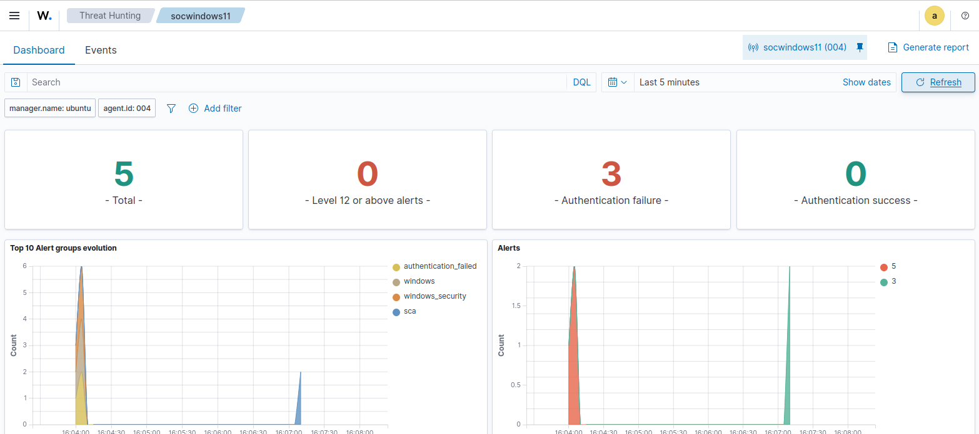
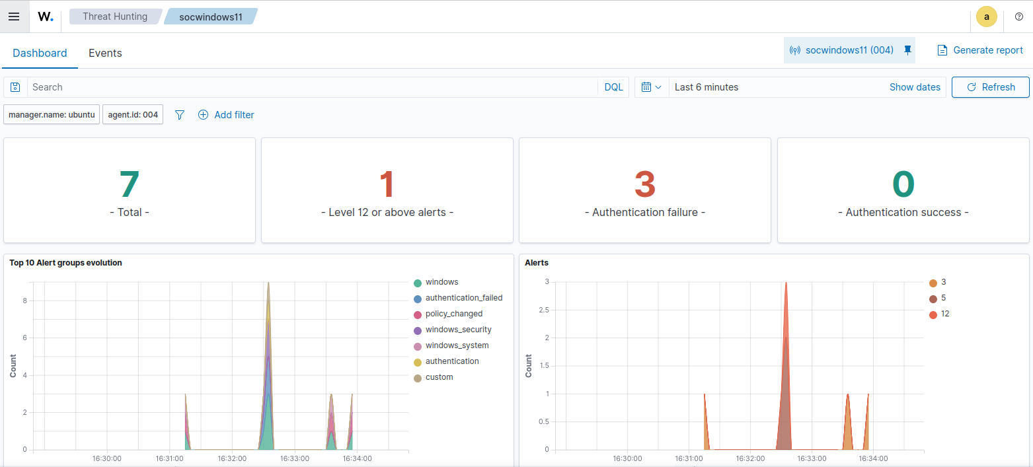

12. Technical Analysis
The implementation demonstrates how Wazuh performs event correlation using frequency and timeframe logic. Instead of treating authentication failures as isolated events, the SIEM aggregates related activity to identify suspicious patterns. This approach reduces alert fatigue while improving detection accuracy for brute-force attempts.

13. Key Learnings
• Understanding difference between single-event alerts and correlation rules
• Practical experience editing local_rules.xml
• Practical use of if_matched_group and if_matched_sid

• Troubleshooting Wazuh configuration errors
• Practical implementation of frequency-based correlation using if_matched_group
• Mapping detection rules to MITRE ATT&CK framework
• Real-world SOC workflow: Configure → Restart → Simulate → Validate → Document

14. Conclusion
The custom correlation rule successfully detected multiple failed Windows login attempts as a brute-force attack. This lab demonstrates applied detection engineering skills relevant to SOC operations, including log analysis, rule tuning, and alert validation. The exercise strengthens practical understanding of SIEM-based security monitoring.

